Project Design Phase Solution Architecture

Date Team ID
Project Name Maximum Marks
3December 2025

SHOPEZ : E-commerce Application

4 Marks

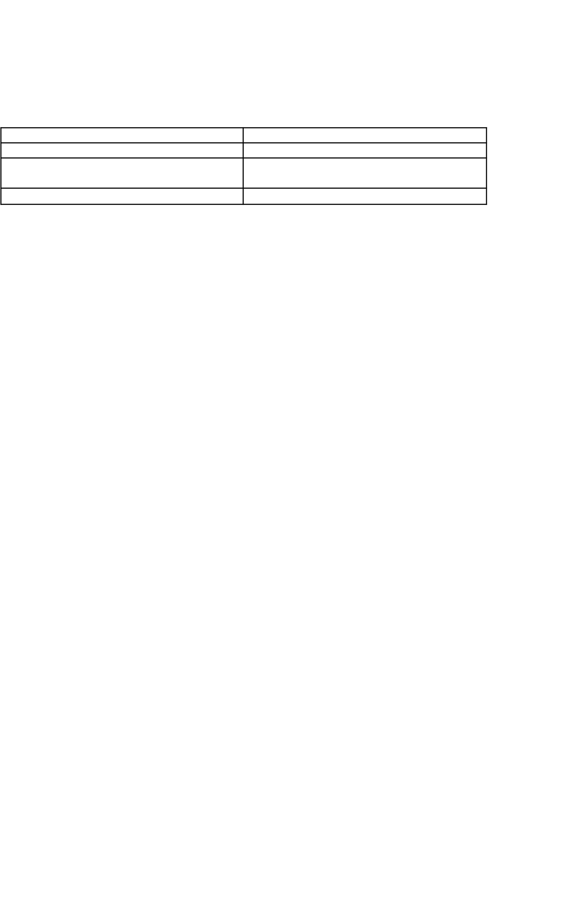
Solution Architecture:
The solution architecture for the E-Commerce Application (ShopEase) is designed to provide a smooth, secure, and efficient buying and selling experience for customers, sellers, and admins.
The platform focuses on fast product discovery, seamless checkout flow, real-time order tracking, secure authentication, and centralized data management to ensure reliability and scalability.

Key Architecture Principles
- Smooth product discovery with advanced search and smart filters
- Secure user/seller/admin authentication
- Real-time updates for stock, orders, and delivery status
- Centralized database for consistent product and order data
- Scalable backend services to support growing users and sellers
- Simple and responsive UI for all roles: Customer, Seller, Admin

Example - Solution Architecture Diagram:

